Concussions Home Page
Concussions
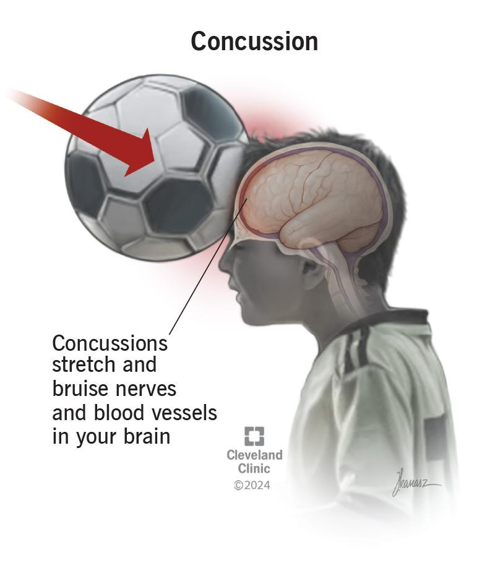Cleveland Clinic, 2024
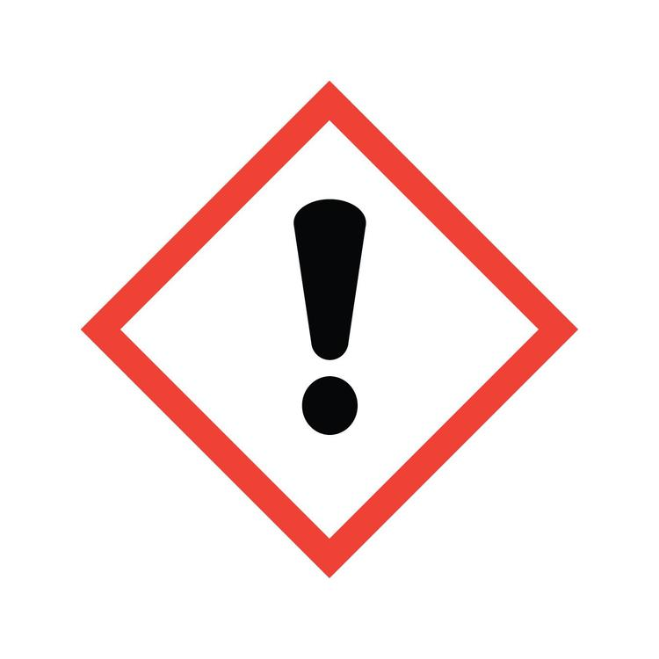 Safety Note : This page should only be used for information, not for diagnosis or treatment and it is not a substitute for medical advice. If you have any symptoms of a concussion, tell an adult and get checked by a health care provider immediately.

What Is This Page About?
This page explains what a concussion is, how it happens, why it should be taken seriously and how you can recognize it. It is written for adolescents and young athletes.

What Is a Concussion?
A concussion is a type of traumatic brain injury (TBI) (CDC, 2025). It affects the abilities of the brain. While concussions are usually known as minor brain injuries, this condition needs to be taken seriously because it influences one's health and well being.

How Does a Concussion Occur?
A concussion is caused by a bump, blow or jolt to the head, or by a hit to the body that makes the head move suddenly and then causes the brain to move accordingly.(CDC,2025). The brain ends up moving around or bouncing in the skull due to sudden force that leads to stretching of the brain tissues and causing chemical changes(Tator,2013).One can sustain this brain injury even when the head is not hit(Cleveland Clinic, 2024).
What happens when you have a concussion? - Clifford Robbins

Symptoms
The symptoms of a concussion may vary depending on the individual. Some of the symptoms may occur soon after the concussion happens, whereas others may only appear after several hours or days(Mayo Clinic Staff, 2022). Symptoms can be felt physically, in thinking abilities, emotions, behavior and sleeping habits.(CDC, 2024) 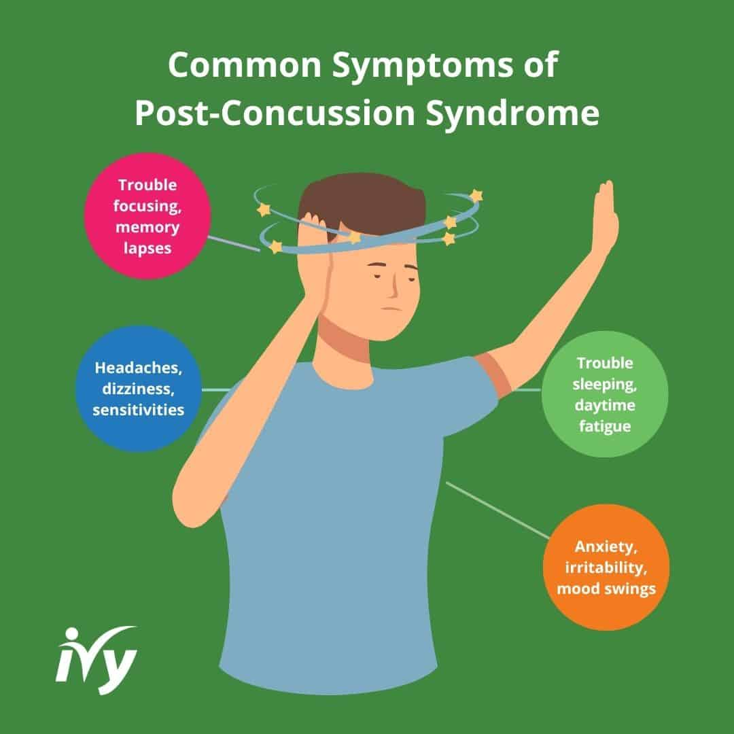Ivy Rehab , 2025
Link to Symptoms Page ( note- should be linked to the symptom page)

What to Do if You Think You Have A Concussion
According to the CDC (2025), you should
- Stop participating in physical activities and don’t continue on the same day.
- Tell an adult.
- Seek advice from a medical professional.
Important To Know
· Most individuals who sustain a concussion recover, but it takes different amounts of time for every individual (CDC, 2025).
· Individuals who have a suspected concussion need to refrain from participating in physical activities, including sport activities, and get themselves checked by a health care practitioner(CDC, 2025).
· Second head impact when an individual has not recovered from the first one makes the situation worse(Tator, 2013).

Risk Factors
- Young Children: Children under the age of 4 have high concussion rates because they are more likely to fall during play or daily activities (American Academy of Pediatrics, 2024).
- Teenagers: Concussions are more common during the teenage years because teenagers often take part in sports and recreational activities (American Academy of Pediatrics, 2024).
- Athletes: Athletes are more prone to concussions because sports can involve falling, tackling, colliding with other players, or being hit during play. Contact sports such as football, soccer, hockey, and basketball have a higher risk (American Academy of Pediatrics, 2024).
- Teen Athletes: Many teenage concussions happen during sports such as cheerleading, football, ice hockey, lacrosse, soccer, and field hockey (Nemours KidsHealth, 2023).
- Sports and Recreation: A CDC report found that some of the highest rates of sports- and recreation-related brain injuries were among children aged 10–14 and 15–17. Football, bicycling, basketball, playground activities, and soccer were linked with high numbers of emergency visits (Sarmiento et al., 2019).

Symptoms
SYMPTOMS

Physical Symptoms (Cleveland Clinic, 2024)

This may include
- Headaches
- Dizziness
- Balance Issues
- Nausea
- Fatigue
- Sensitivity to light or noise.
- Double or blurred vision
- Neck pain
- Hearing problems may also develop

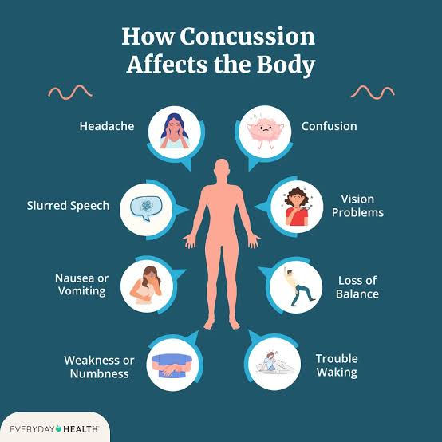(Everyday Health, 2022)

Behavioral and Cognitive Symptoms
These may include ((CDC, 2024; Cleveland Clinic, 2024 ; Mayo Clinic Staff, 2022)
- Memory problems
- Poor thinking ability
- concentration during studying in school.
- mental slowing,
- confusion
- distractions.
- changes in one's sleeping, mood and behavior,such as irritability or anxiety

Myths
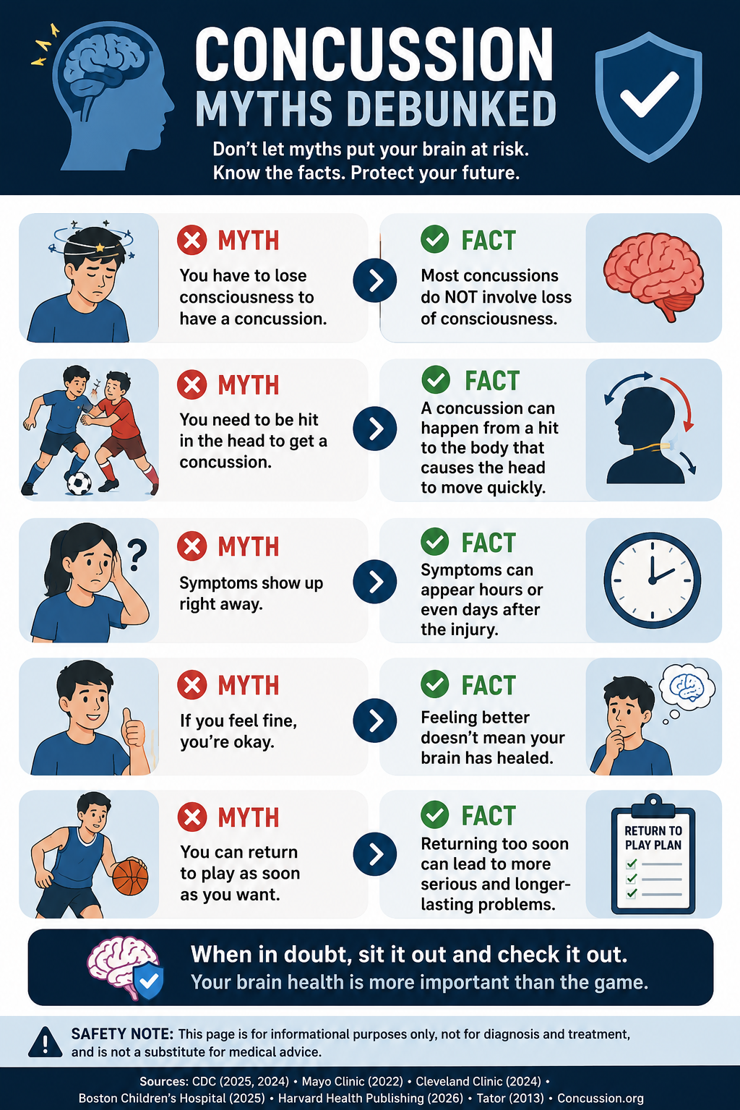

Myth 1 - Don’t sleep right after a concussion
It is often believed that when someone suffers from a concussion, they have to stay awake. If the concussion is mild, then sleep will assist in the healing process as the body needs to rest and recuperate(CDC, 2025). However, before one goes to sleep, they have to determine whether there are signs of severe concussion or a worsening of symptoms(CDC, 2025).

If the person does not suffer from a severe concussion but experiences mild symptoms and is forced to stay awake, they will feel exhausted and the healing process will be delayed due to fatigue(CDC, 2025).

Myth 2 - You have to lose consciousness to have a concussion

It is often believed that a person does not have a concussion unless you lose consciousness. The reality , however, is that a concussion can happen from a jolt or a sudden bump to the head and does not always lose conscience (Mayo Clinic Staff, 2022). It can be an effect but it is never mandatory for having a concussion (Mayo Clinic Staff, 2022).
This becomes important to understand because then people will ignore if they really have a concussion only if they have to lose consciousness which is why a person needs to be aware about this. Due to this, the person’s symptoms can worsen and become dangerous.
Therefore , the belief that you have to lose consciousness to have a concussion is incorrect.(CDC)

Myth 3 - Symptoms show up right away

The correct understanding for this myth is the complete opposite. Symptoms do not show up right away and it will take time to show. Some do show up right away while others can take several hours to start acting. This is important because if a person assumes

References

References
American Academy of Pediatrics. (2024, December 5). Concussions in children & teens: What parents need to know. HealthyChildren.org. https://www.healthychildren.org/English/health-issues/injuries-emergencies/sports-injuries/Pages/Concussions.aspx
Centers for Disease Control and Prevention. (2024). Signs and symptoms of concussion. HEADS UP. https://www.cdc.gov/heads-up/signs-symptoms/index.html
Centers for Disease Control and Prevention. (2025). Concussion basics. HEADS UP. https://www.cdc.gov/heads-up/about/index.html
Cleveland Clinic. (2024). Concussion: Causes, symptoms, diagnosis, treatments, prevention. https://my.clevelandclinic.org/health/diseases/15038-concussion
Concussions in children. (2025). Childrenshospital.org. https://www.childrenshospital.org/conditions-treatments/concussions
Everyday Health. (2022). Concussion symptoms. https://www.everydayhealth.com/concussion/symptoms/
Harvard Health Publishing. (2026, January 22). Concussion. https://www.health.harvard.edu/a_to_z/concussion-a-to-z
Ivy Rehab. (2025). Treatment for post-concussion syndrome. https://ivyrehab.com/health-resources/concussion/treatment-for-post-concussion-syndrome/
Mayo Clinic Staff. (2022). Concussion—Symptoms and causes. Mayo Clinic. https://www.mayoclinic.org/diseases-conditions/concussion/symptoms-causes/syc-20355594
MedlinePlus. (2025, November 24). Concussion. National Library of Medicine. https://medlineplus.gov/concussion.html
National Health Service. (2025, May 29). Head injury and concussion. https://www.nhs.uk/conditions/head-injury-and-concussion/
Nemours KidsHealth. (2023). Concussions (for teens). https://kidshealth.org/en/teens/concussions.html
Sarmiento, K., Thomas, K. E., Daugherty, J., Waltzman, D., Haarbauer-Krupa, J. K., Peterson, A. B., Haileyesus, T., & Breiding, M. J. (2019). Emergency department visits for sports- and recreation-related traumatic brain injuries among children—United States, 2010–2016. Morbidity and Mortality Weekly Report, 68(10), 237–242. https://doi.org/10.15585/mmwr.mm6810a2
Tator, C. (2013). Concussions and their consequences: Current diagnosis, management and prevention. Canadian Medical Association Journal, 185(11), 975–979. https://doi.org/10.1503/cmaj.120039

Notes TBD

NEW SOURCES FOR YOUR WEBSITE

All of these are reliable and easy to read. For each source you get the website, the page's date, what to use it for, and one sentence from it. Read the page yourself before you use it, and write the idea in your own words.

HOME PAGE

1. NHS - Head injury and concussion
https://www.nhs.uk/conditions/head-injury-and-concussion/
Page reviewed: 29 May 2025
Use it for: a simple definition, and when to call for emergency help.
Key sentence: A concussion is "a temporary brain injury" that "can last a few weeks."

2. MedlinePlus - Concussion
https://medlineplus.gov/concussion.html
Page updated: 24 November 2025
Use it for: what a concussion is and what causes it.
Key sentence: "A concussion is a type of brain injury. It involves a short loss of normal brain function."

3. KidsHealth for Teens - Concussions
https://kidshealth.org/en/teens/concussions.html
Reviewed by a doctor: July 2023
Use it for: this page is written for teenagers, just like your website. It also explains when you can go back to school and sports.
Key sentence: "Stay out of all sports and any activities that could lead to head injury... until your symptoms are completely gone."

SYMPTOMS PAGE

1. HealthyChildren.org (American Academy of Pediatrics) - Concussions in Children & Teens
https://www.healthychildren.org/English/health-issues/injuries-emergencies/sports-injuries/Pages/Concussions.aspx
Page updated: 5 December 2024
Use it for: a clear list of symptoms, including signs other people can see.
Key sentence: "These symptoms often start right after the injury, but in some cases, may take up to a few days for them to occur."

2. MedlinePlus - Concussion
Use it for: symptoms that show up later, and serious signs that need a doctor right away.
Key sentence: "Symptoms of a concussion may not start right away; they may start days or weeks after the injury."

3. KidsHealth for Teens - Concussions
Use it for: symptoms explained in simple words, like feeling sluggish, trouble focusing, sleep problems and anxiety.

RISK FACTORS PAGE

1. HealthyChildren.org (American Academy of Pediatrics)
Use it for: how age and sports affect risk.
Key points: concussions are "more common during the teen years." Children under 4 have the highest rates. Contact sports like football, soccer, hockey and basketball have a higher risk.

2. KidsHealth for Teens - Concussions
Use it for: which sports teens get concussions in.
Key sentence: most teen concussions happen in sports, "particularly cheerleading, football, ice hockey, lacrosse, soccer, and field hockey."

3. CDC report - Sports and recreation brain injuries in children (2019)
https://doi.org/10.15585/mmwr.mm6810a2
Use it for: real numbers from the US government. Start with the short summary box at the top of the report.
Key sentences: "The highest rates were among males and children aged 10-14 and 15-17 years." "Activities associated with the highest number of ED visits were football, bicycling, basketball, playground activities, and soccer."

MYTHS PAGE

1. KidsHealth for Teens - Concussions
Myth 1 (sleep): "You can sleep if you feel tired. (No need to have someone wake you up to check on you unless your health care provider told you to.)"
Myth 2 (passing out): concussions "can happen without a person being knocked out."
Ideas for another myth: helmets do not prevent concussions, and concussions do not show up on CT or MRI scans.

2. NHS - Head injury and concussion
Myth 1 (sleep): you "do not need to stay awake if you're tired."

3. HealthyChildren.org (American Academy of Pediatrics)
Myth 1 (sleep): you "won't have to periodically wake up your child while they are sleeping."
Myth 3 (symptoms): symptoms usually start right away, but "may take up to a few days."

SOMETHING TO THINK ABOUT

Your sources give different times for when symptoms can show up:
CDC says "hours or days."
HealthyChildren.org says "up to a few days."
MedlinePlus says "days or weeks."
None of them is wrong. When you write, say what your source says, and cite that source.

READY-MADE REFERENCES (APA)

Add these to your reference list when you use them.

American Academy of Pediatrics. (2024, December 5). Concussions in children & teens: What parents need to know. HealthyChildren.org. https://www.healthychildren.org/English/health-issues/injuries-emergencies/sports-injuries/Pages/Concussions.aspx

MedlinePlus. (2025, November 24). Concussion. National Library of Medicine. https://medlineplus.gov/concussion.html

National Health Service. (2025, May 29). Head injury and concussion. https://www.nhs.uk/conditions/head-injury-and-concussion/

Nemours KidsHealth. (2023). Concussions (for teens). https://kidshealth.org/en/teens/concussions.html

Sarmiento, K., Thomas, K. E., Daugherty, J., Waltzman, D., Haarbauer-Krupa, J. K., Peterson, A. B., Haileyesus, T., & Breiding, M. J. (2019). Emergency department visits for sports- and recreation-related traumatic brain injuries among children - United States, 2010-2016. Morbidity and Mortality Weekly Report, 68(10), 237-242. https://doi.org/10.15585/mmwr.mm6810a2

How to cite them in your text:
(American Academy of Pediatrics, 2024)
(MedlinePlus, 2025)
(NHS, 2025)
(Nemours KidsHealth, 2023)
(Sarmiento et al., 2019)

SUPPORTIVE INFORMATION
First Page Outline

- Definition of Concussions – Traumatic Brain Injury
- Mechanism – Kinetic Movement of brain
- Causes – by a jolt to the skull
- Symptoms
- Physical symptoms – Headaches, vision, neck pain, hearing
- Behavioral Symptoms – Struggle in learning, focus, sleep and thinking
- General Information
- Risk Factors – Athletes, Middle aged, adolescents

- Sections which are missing: Statistics, Images, Safety, Videos, Design of Site
Add more information to existing sections

Decide about TO KNOW PAGE
Should not include exact info as home page

